

**COMSATS University Islamabad (Lahore Campus)**

**<Lab Assignment 1> – SPRING 2024**

|  |  |  |  |  |  |
| --- | --- | --- | --- | --- | --- |
| Course Title: | Game Development | Course Code: | CSC495 | Credit Hours: | 3 |
| Course Instructor/s: | Saira Aslam | Program | BSE | | |
| **Submission Deadline** | **2:30 pm, 5-3-2024** | **Maximum Marks:** | **50** | | |
| **Important Instructions / Guidelines:**   * Submit a 10 seconds video, 4 screenshots, and all your scripts in Lab Assignment 1 submission at google classroom * Paste your screenshots and scripts inside Lab Assignment-1 submission file provided | | | | | |

***Question No 1.***

***CLO: <3>; Bloom Taxonomy Level: <****Apply****>* [80]**

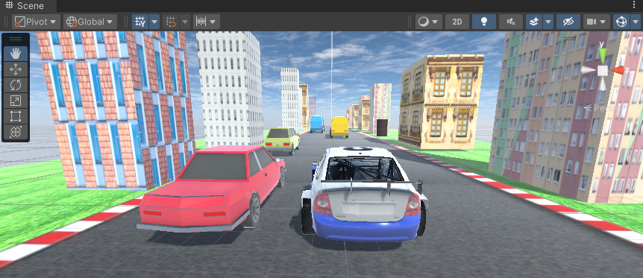

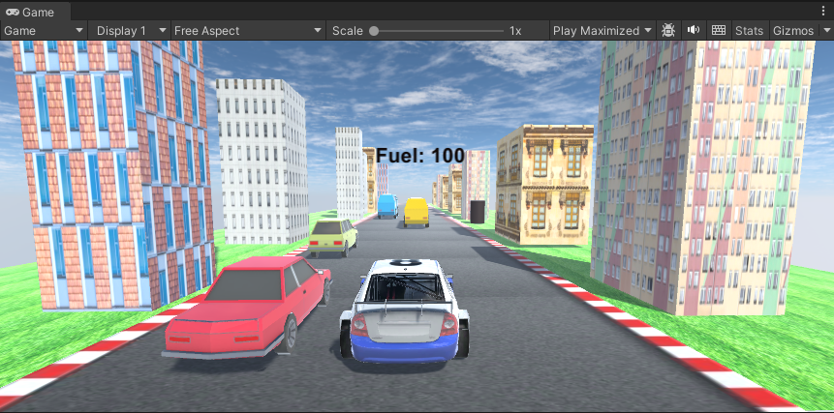

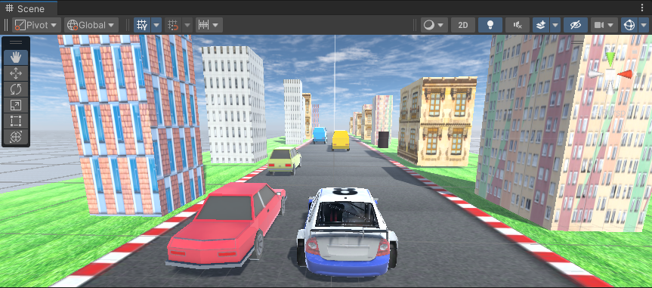

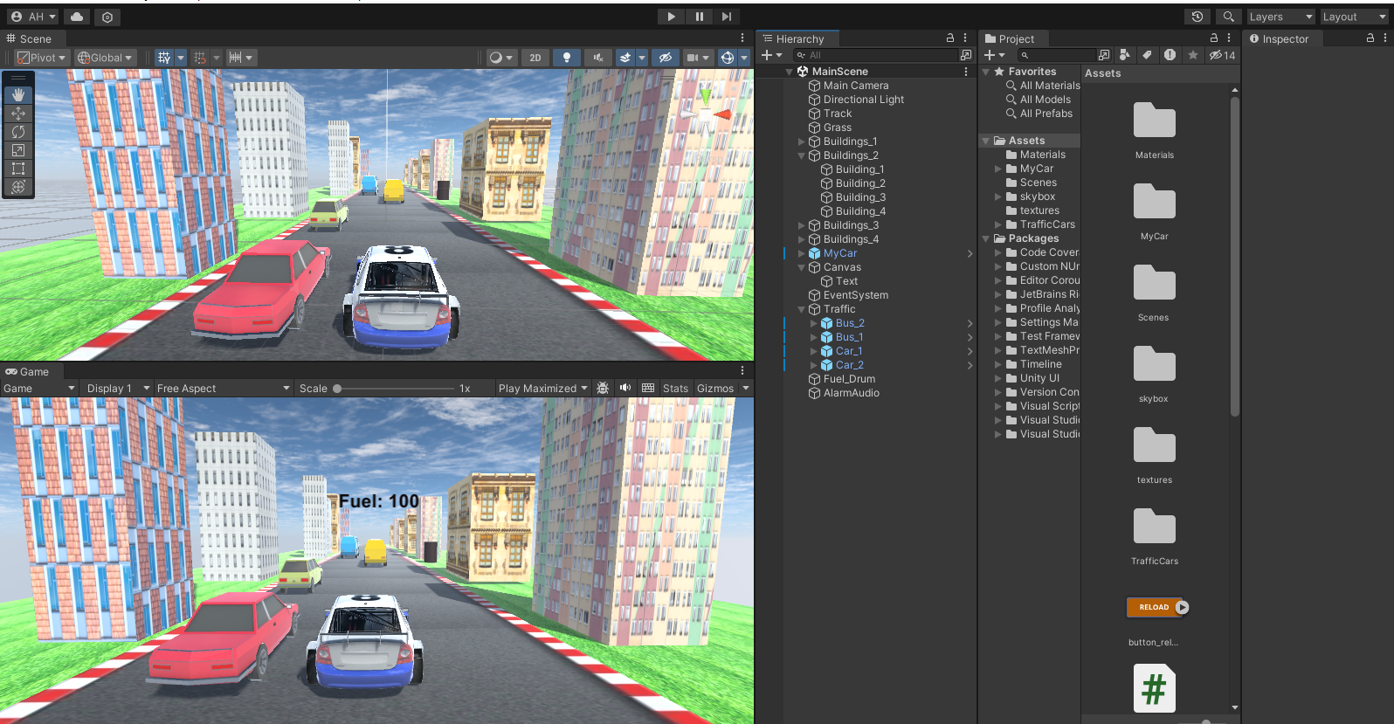

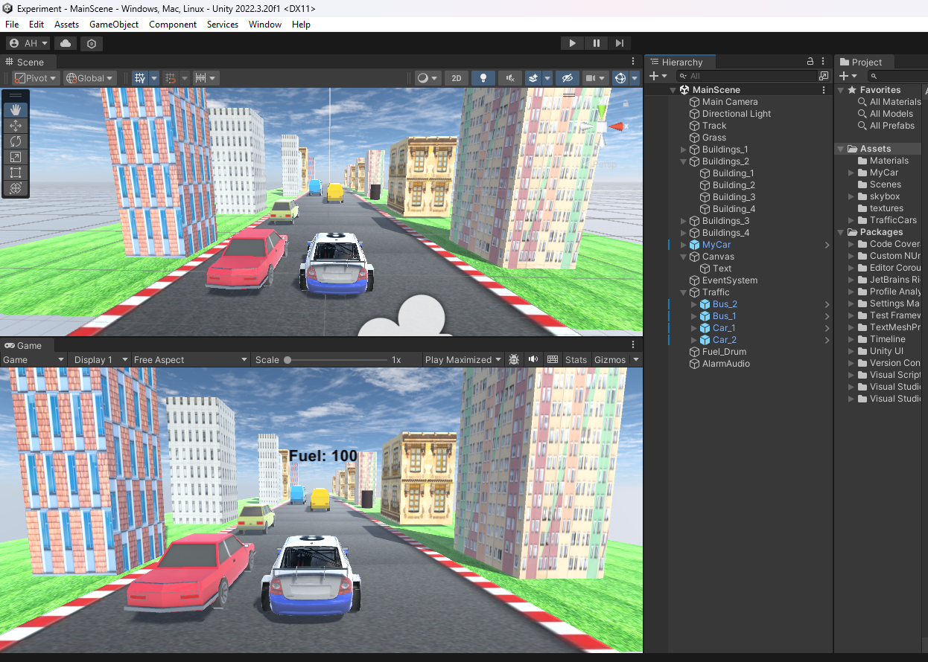

**carScript.cs**

//Task: provide action for car reached at the end of the road and starts automatically from start

using System.Collections;

using System.Collections.Generic;

using UnityEngine;

using UnityEngine.UI;

using UnityEngine.SceneManagement;

using System.Runtime.CompilerServices;

public class carScript : MonoBehaviour

{

    public float leftRotateStrength = -0.5f;

    public float rightRotateStrength = 0.5f;

    public AudioSource AlarmAudio;

    float fuelValue = 500;

    public Text fuelText;

    public Text lowFuelText;

    public GameObject drum;

    // Start is called before the first frame update

    void Start()

    {

        fuelText.text = "Fuel: " + fuelValue.ToString();

        lowFuelText.text = "";

        AlarmAudio = GetComponent<AudioSource>();

    }

    // Update is called once per frame

    void Update()

    {

      if(Input.GetKey(KeyCode.UpArrow)) //forward move

      {

        transform.Translate(0,0,0.5f);

            fuelValue -= 1;

            fuelText.text = "Fuel: " + fuelValue.ToString();

      }

      if(Input.GetKey(KeyCode.LeftArrow)) //left rotation

      {

        transform.Rotate(0,leftRotateStrength,0);

      }

      if(Input.GetKey(KeyCode.RightArrow)) //right rotation

      {

        transform.Rotate(0,rightRotateStrength,0);

      }

      //move the car from ending to starting position again

      Vector3 carPos = transform.position;

      if(carPos.z > 90) //ending position of z: 90

      {

        carPos.z = -90; //starting position of z

        transform.position = carPos;

      }

      if(fuelValue <= 20)

      {

        fuelText.text = "Fuel is Low!";

        AlarmAudio.Play();

      }

      if(fuelValue <= 0)

      {

         SceneManager.LoadScene("GameOver");

      }

    }

    private void OnCollisionEnter(Collision col)

    {

      if(col.gameObject.CompareTag("abc"))

      {

          //Debug.Log("Collided!");

          fuelValue = 500;

          //fuelText.text = "Fuel value is: " + fuelValue.ToString();

          Destroy(col.gameObject);

          //AlarmAudio.mute = true;

      }

      if(col.gameObject.name.StartsWith("Car_1") || col.gameObject.name.StartsWith("Car_2") || col.gameObject.name.StartsWith("Bus_1") || col.gameObject.name.StartsWith("Bus_2"))

      {

        fuelValue -= 5f;

      }

    }

}

**trafficScript.cs**

using System.Collections;

using System.Collections.Generic;

using UnityEngine;

public class trafficScript : MonoBehaviour

{

    // Start is called before the first frame update

    void Start()

    {

    }

    // Update is called once per frame

    void Update()

    {

        transform.Translate(0,0,0.1f);

        Vector3 trafficPos = transform.position;

        if(trafficPos.z > 90)

        {

            trafficPos.z = -90;

            transform.position = trafficPos;

        }

    }

}

**cameraScript.cs**

using System.Collections;

using System.Collections.Generic;

using UnityEngine;

public class cameraScript : MonoBehaviour

{

    public GameObject car;

    Vector3 offset;

    // Start is called before the first frame update

    void Start()

    {

        offset = transform.position - car.transform.position;

    }

    // Update is called once per frame

    void Update()

    {

        transform.position = offset + car.transform.position;

    }

}